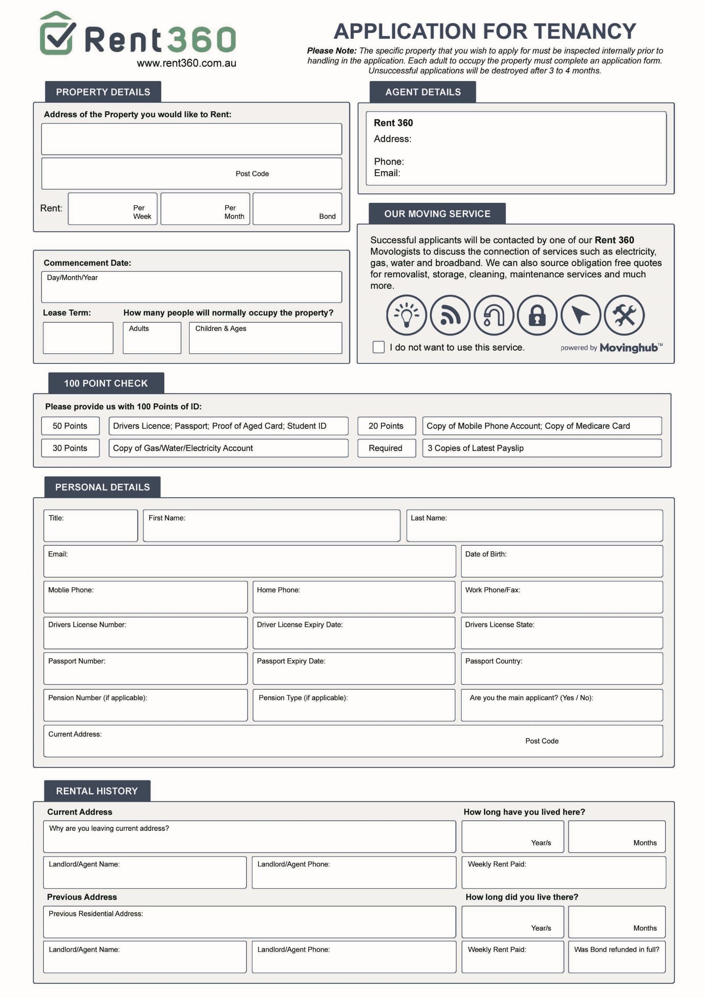

**Rent 360 Gold Coast, 1/10 Albert Ave, Broadbeach 4218**

**Donna Goodall 0466 824 381 or 1300 800 360**

**Donna.goodall@rent360.com.au**

$

$

$









$

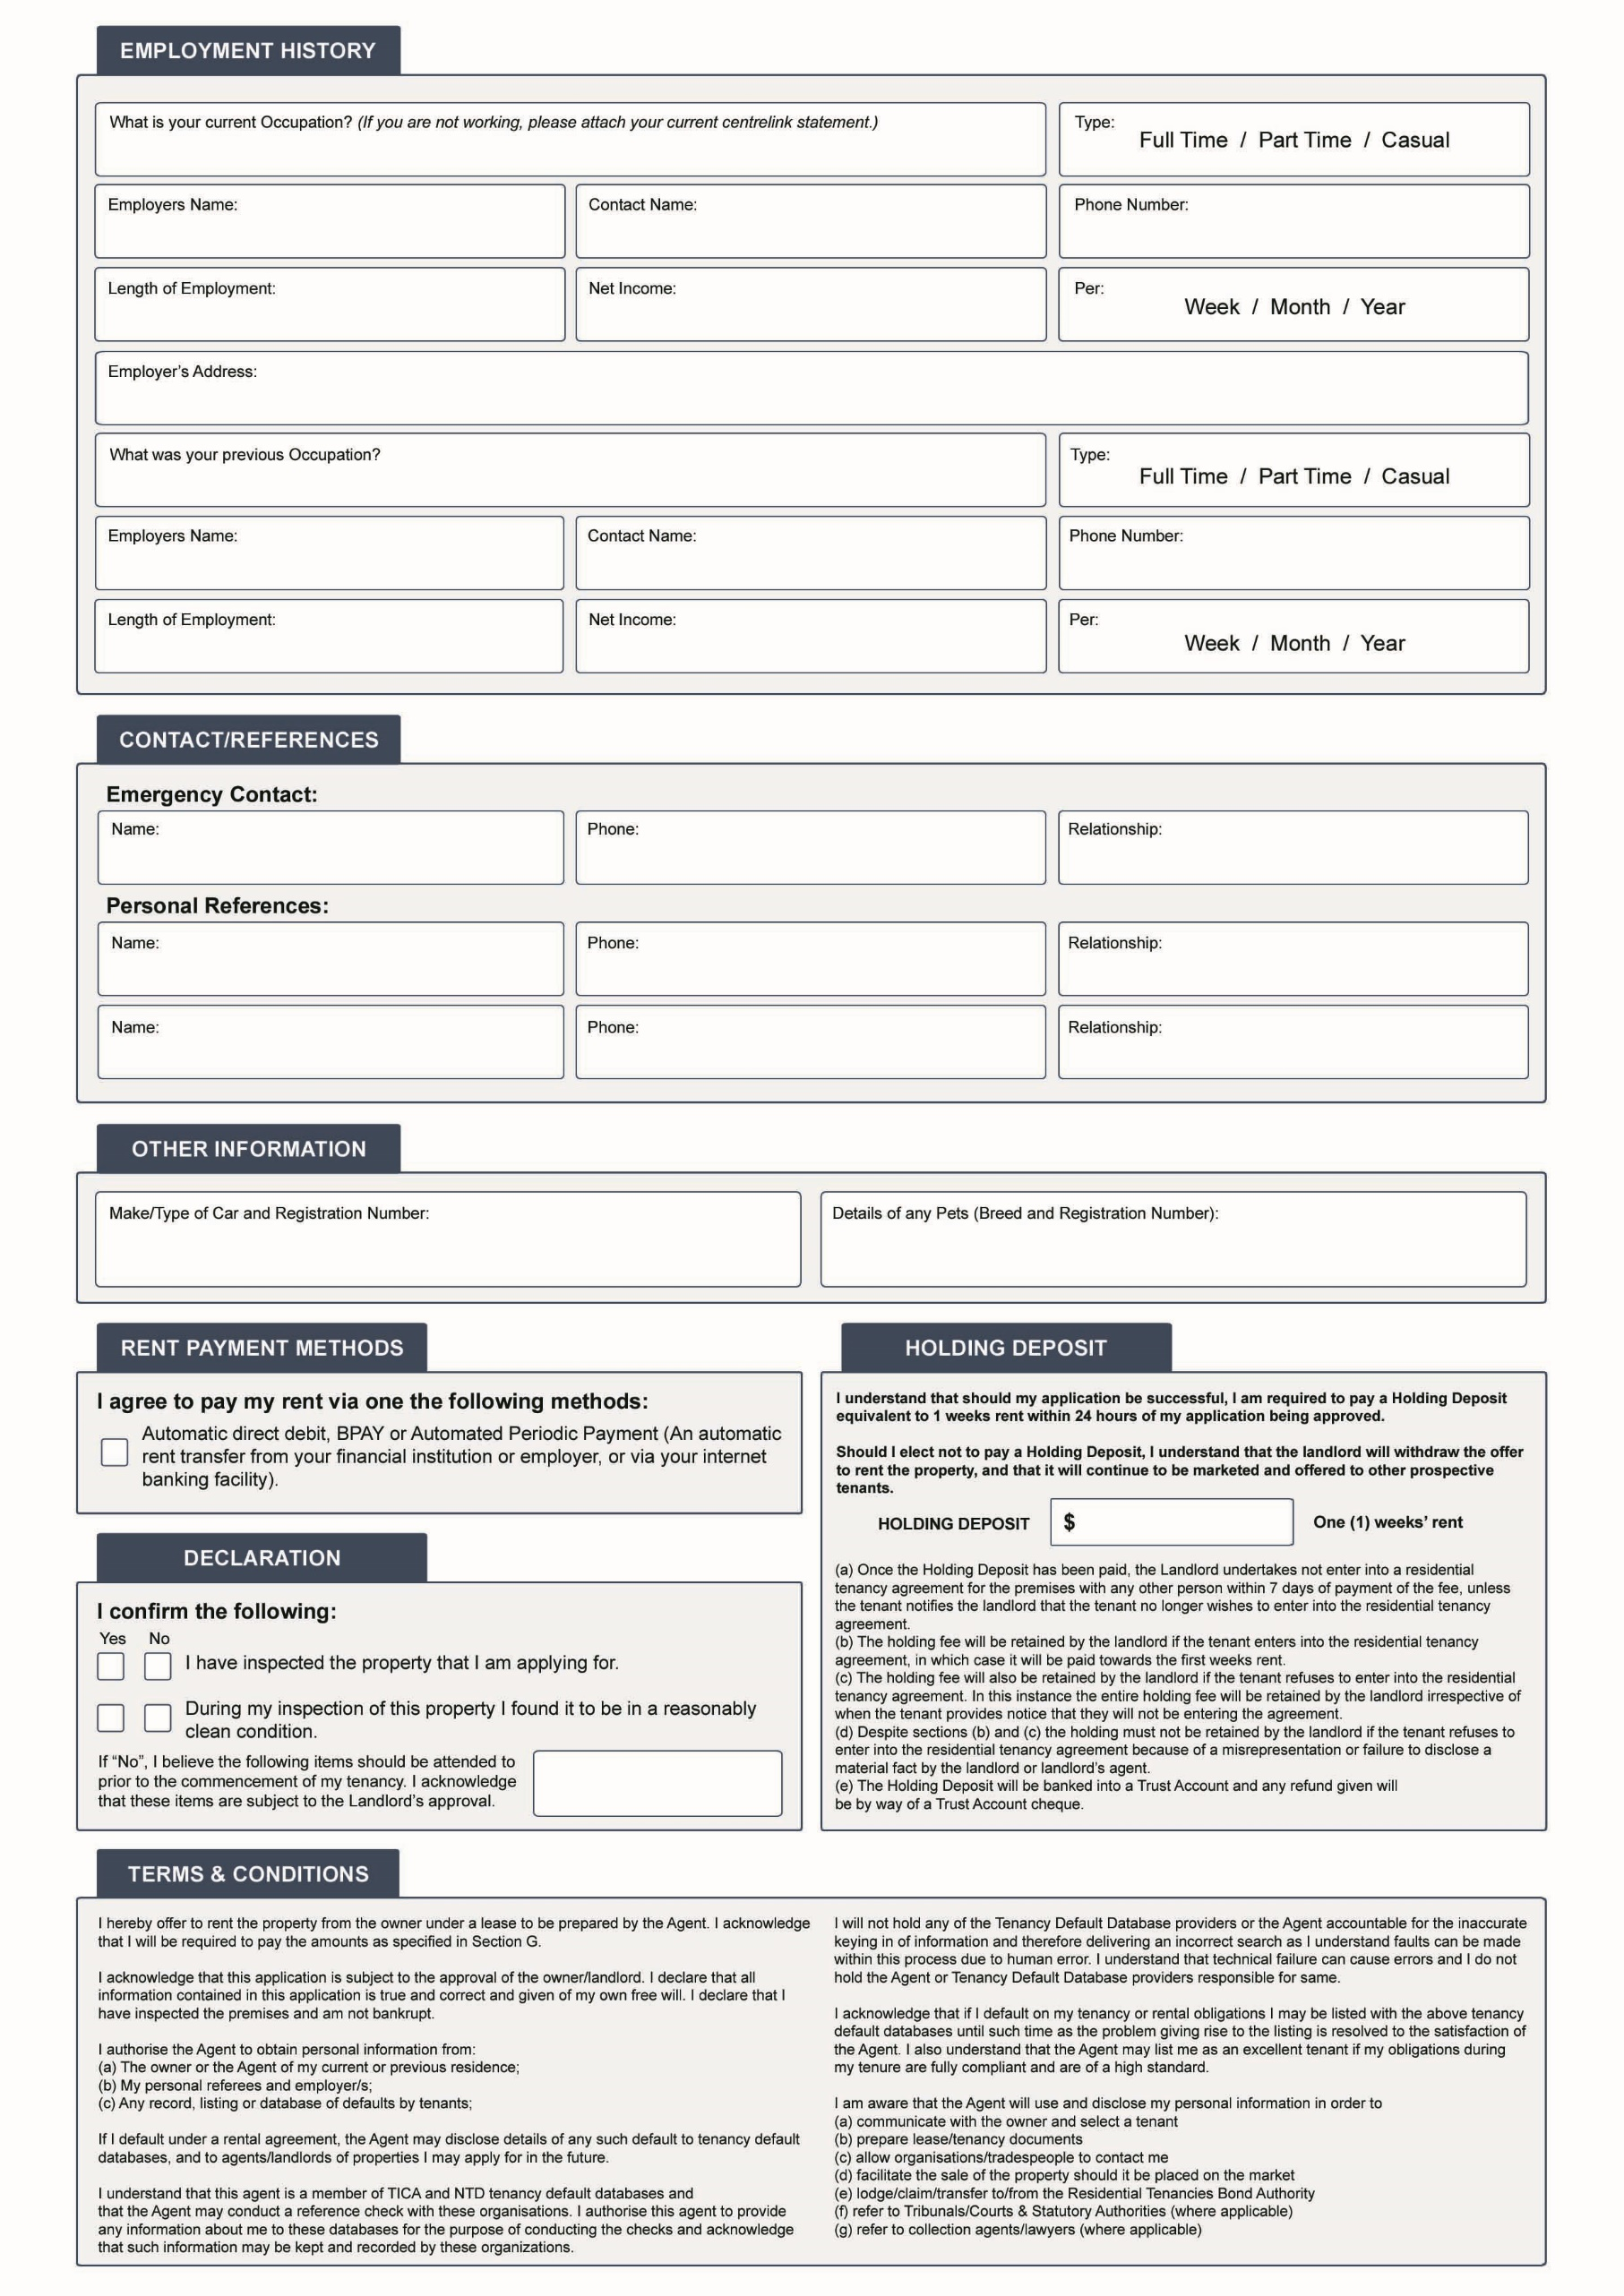

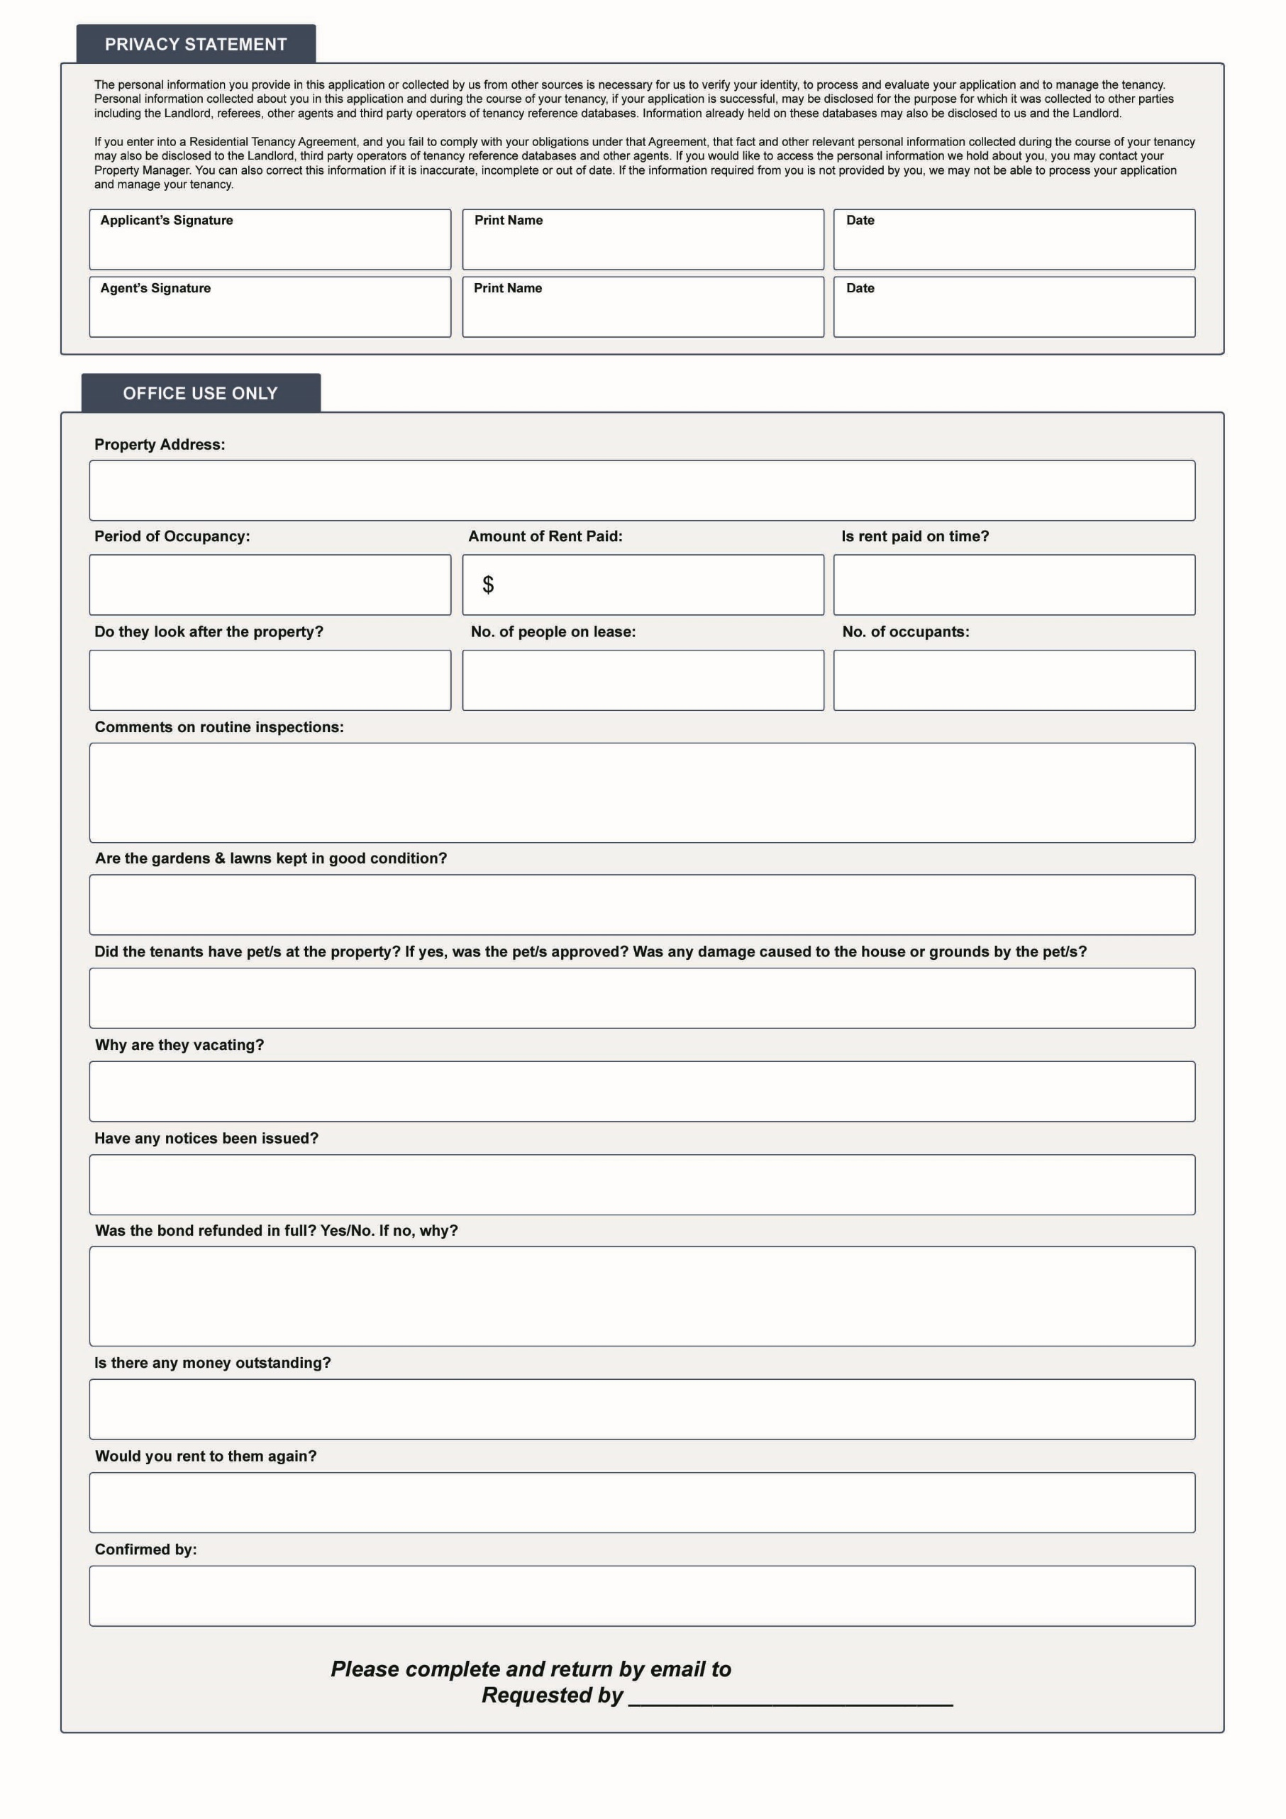

***Donna Goodall | Property Manager***

***Debra Gray|Operations Manager***

***donna.goodall@rent360.com.au @rent360.com.au***